Anime Recommendation system using Content-Based Filtering (CBF) and Sentiment Analysis Hybrid
Kapil Singh Negi
SoCS, UPES, Dehradun, Uttarakhand, India
kapil.negi12300@gmail.com

ABSTRACT

Purpose – The global anime market was valued at over $24 billion in 2021 and is projected to reach over $60 billion by 2030. With its wide range of genres and unique visual characters, anime is a popular form of animation with a large global audience. Tens of thousands of anime have been produced, and it is simple for an anime to go unnoticed. The majority of anime fans mainly watch anime based on recommendations from friends, which is hardly efficient; most viewers become biased, and many excellent anime are missed by the intended audience. This paper proposes an AI anime recommendation system that addresses this very problem. It minimizes the bias introduced by the majority of the recommendary systems, using content-based filtering (CBF) and concentrates more on the context and theme of anime to better suit the needs of the user while still being able to use the pros of CBF, allowing him to find anime that suits his taste rather than being forced to watch the popular series.
Research limitations/implications The research is limited by the scope of the dataset used and the system is severely hampered when dealing with new users (no history). The vast, mostly empty user-item matrix challenges the training of the Deep Collaborative Filtering (CF) model, especially for niche recommendations. Explicit feedback is non-neutral, as highly engaged users often only rate extreme preferences (love/hate), introducing selection bias into the training data.

- INTRODUCTION

The art, animation techniques, production, and process of anime are different from those of other animation genres. Anime displays a diverse range of visual styles that vary throughout creators, artists, and companies. Although anime is not dominated by any one art form, there are certain similarities among them in terms of character design and animation methods.

Children's, girls', boys', young men's, young women's, and a wide variety of genres aimed at an adult audience are among the many target demographics used to categorize anime. In an effort to appeal to a wider audience, shōjo and shōnen anime occasionally include features that are well-liked by kids of all genders. In addition to adult themes and events, adult anime may have a slower pacing or more intricate plots that younger viewers could find uninteresting.

Over 200 animation works are aired in Japan each year, and the industry for animation as a whole, including associated products, has grown to be worth about 1.8 trillion yen in recent years. Anime is a popular form of animation with a large global audience with audience from many age groups and diverse cultures. Along with the audience the anime has also evolved from just being influenced by Japanese to many other cultures. Some international successes include Sailor Moon and Dragon Ball Z, both of which were dubbed into more than a dozen languages worldwide.

With the growing supply and demand in the anime it is only getting difficult for anime fans to find the anime which suits their interest, for the majority the type of anime they watch is highly influenced by their peer group as an anime fan can only go reliably to his friends to get a good recommendation. But this method is imperfect, as most times it just so happens that one person ‘person A’ likes some anime and wishes to know if there are more anime like this, his friend ‘person B’ may not know of more anime like that because the type he ‘person B’ watches are of a different genres, animation style or differently paced in such cases anime fan ‘person A’ needs to scrape the internet starting reddit comment chain, joining discords and what not.
With this research I aim to significantly ease the burden on people in similar situation to ‘person A’ including myself using a artificially intelligent system that can identify the type of content ‘person A’ enjoys watching and recommend me similar content.

In this paper I will be using Content based filtering and unsupervised Natural language processing on the dataset [https://www.kaggle.com/datasets/dbdmobile/myanimelist-dataset]
For the sake of simplicity, I will be using only animedataset-2023.csv and users-score-2023.csv files within the dataset. The synopsis data will be used for finding anime with similar plot according to the lexical similarity, and the rest of features will be used for Content-Based filtering

For Lexical similarity analysis, TF-IDF will be the preferred method to convert textual data into numeric weights, as for the prediction model the primary focus will be on Information Retrieval technique using cosine similarity.
For Content-Based filtering the database will be optimised using multi hot encoding and one hot encoding for categorical data in features. We will apply dot product for ranking the relevance.
Finally, we will fuse the results thus obtained using a weighted scoring with one hyper parameter (alpha).

The advantages of hybrid model are
1. It handles the Item Cold Start Issue Effectivley: CBF relies on item’s metadata and it’s features rather than user interactions to make recommendations.
2. It refines similarity: two Action/Adventure shows may have structural similarities, but the plot distinguishes between the whimsical, lighthearted or the gritty, dark one.

To process the database, we must perform two things first to process the synopsis column using TF-IDF to data into numeric weights by
1. Lowercasing and Punctuation Removal
2. Tokenization and Stop Word Removal
3. Lemmatization
4. Then calculating TF-IDF

For the rest of the features, we will use multi hot encoding and one hot encoding to optimize the database for machine learning.
The database will be divided into 60% testing data and 40% testing data since I am working with relatively small amount of data.
Then to find cosine similarity of synopsis TF-IDF an change its relevance based on the user’s rating, similarly we will find dot product and scale it according to the user’ rating and finally tuning the hyper parameter to assign weight to CBF score and Synopsis analysis score

This hybrid score will be needed to be fine-tuned by brute force approach using grid searching.

Finally, I will be comparing this hybrid model with baseline-
Pure CBF: Using only the metadata columns.
Pure LA: Using only the Lexical analysis for similarity.

- RELATED WORK

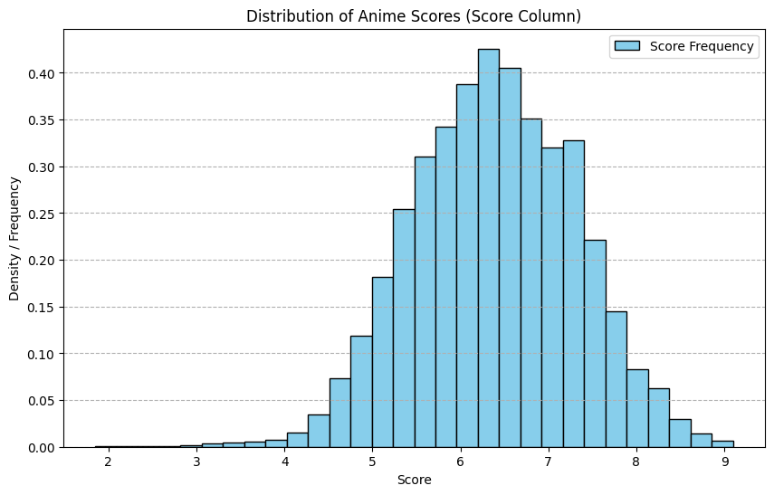 Distribution of anime scores in database

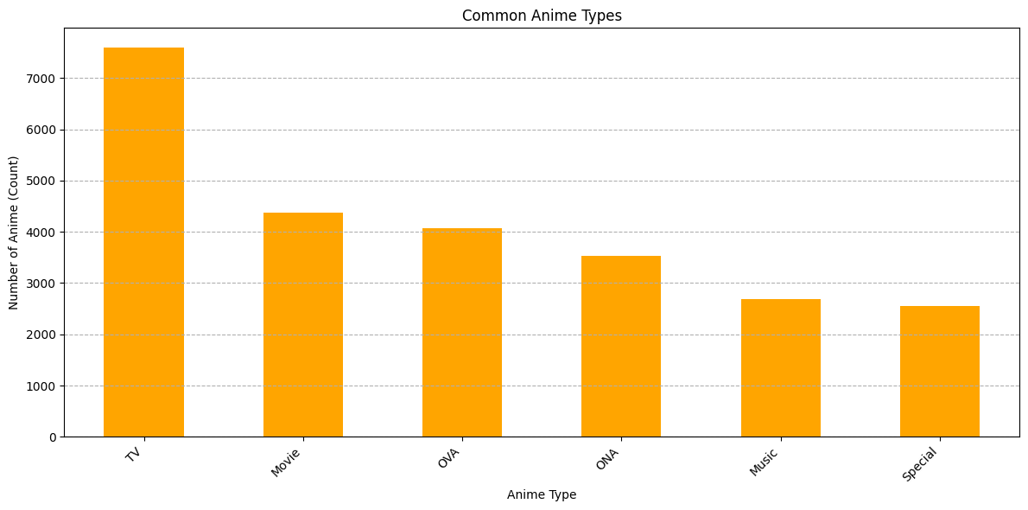
Most common anime types in the database

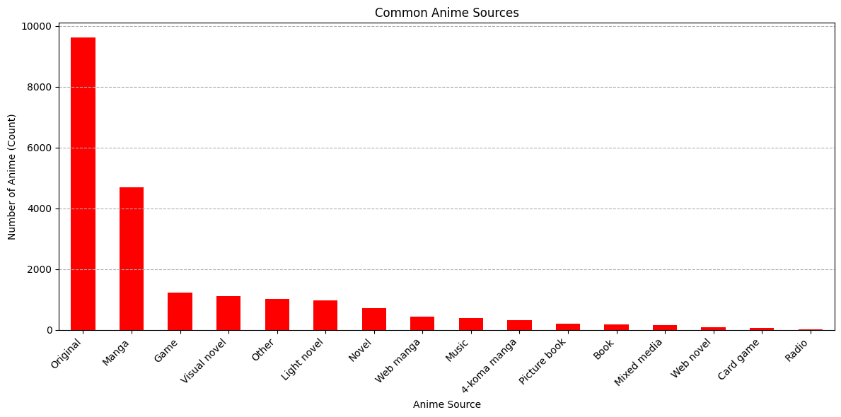
Most common anime sources

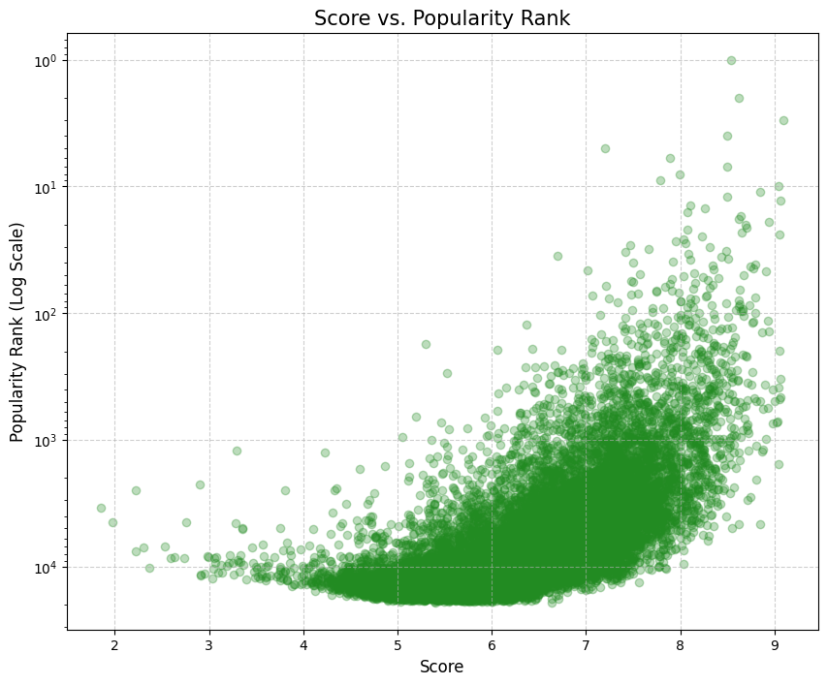
Score vs Popularity

To process the database, we have to perform two things first to process the synopsis column using TF-IDF to data into numeric weights by
1. Lowercasing and Punctuation Removal
2. Tokenization and Stop Word Removal
3. Lemmatization
Then converting this into TF-IDF,
1.Calculate Term Frequency (TF) for each word in each document
2) Calculate the Inverse Document Frequency (IDF) for each word
3) Multiply the TF and IDF values for each word to get its TF-IDF score

For the rest of the features, we will use label encoding and one hot encoding to optimize the database for machine learning.

The database will be divided into 60% testing data and 40% testing data since I am working with relatively small amount of data

Then to apply logistic regression on the synopsis data, and cosine similarity to other features and combining them via weighted scoring to calculate a hybrid score

This hybrid score will be needed to be fine-tuned manually.

Finally, I will be comparing this hybrid model with baseline-
Pure CBF: Using only the metadata columns.
Pure SA: Using only the sentiment score for similarity.

- REFERENCES

- W. K. Tan and R. M. F. R. M. N. Rashid, “Intelligent Mobile Agents-Based System for Healthcare Monitoring,” in Advances in Computing and Data Sciences, S. Singh, A.K. Kar, V.K. Singh, and N.S. Raghuwanshi, Eds. Cham, Switzerland: Springer.
- Puji Lestari. 2012. A New Concept in Developing English-Indonesian Digital Dictionary with Semantic Network Model. (Undergraduate Thesis, UIN Maulana Malik Ibrahim, Malang, Indonesia).
- dbdmobile. 2025. MyAnimeList Dataset. (Accessed Oct. 2025), Available: https://www.kaggle.com/datasets/dbdmobile/myanimelist-dataset
- Anime. (Accessed Oct. 2025), Available: https://en.wikipedia.org/wiki/Anime#Markets

